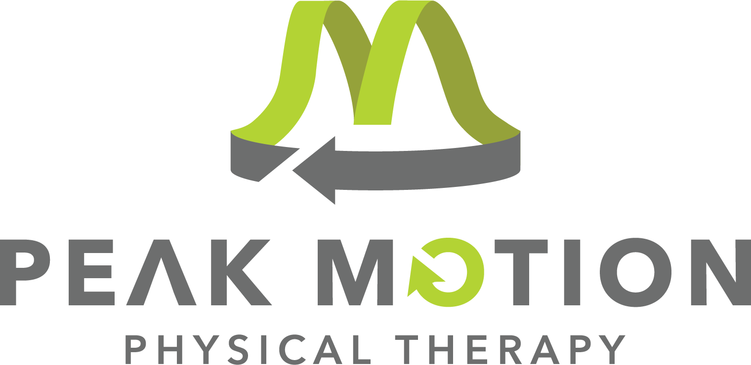

Do you want to grow with us?
Do you want to be a part of a team where collaboration is key and each team member matters? Are you interested in a holistic approach to treating your patients? Are you eager to learn and grow as a clinician? Then, join the Peak Motion Physical Therapy team! Peak Motion Physical Therapy is a privately and locally PT-owned, growing company situated in small communities of the northern Black Hills of South Dakota and Wyoming; perfect for raising families and/or outdoor enthusiasts. We value clinical and professional growth and provide mentorship to our teammates to set them up for success. At Peak Motion Physical Therapy, you are not just another employee; you are part of the team!

POSITION SUMMARY:
Peak Motion is seeking a driven clinician with passion for serving members of the community so that they can live life at their peak. Our ideal teammate is self-motivated with a desire to grow professionally, providing best-in-class care and exceptional patient outcomes. Interested in learning more? We invite you to apply today so we can connect with you!
As an outpatient, and inpatient, clinician, you will have the opportunity to work with a wide variety of patients, ranging from children to older adults. Treatment is individualized to each patient, as sessions are one-to-one, allowing you to be flexible with their plan of care. A rewarding part of your role will be collaboration with your fellow teammates! Our clinics also employ occupational therapists, which allows you the opportunity to work together to drive patient success.

OUR VALUES: Service (patient and community focus). Growth (holistic growth of patients and staff). Innovation (utilizing cutting edge treatment methods to provide the best patient outcomes).

OUR MISSION: Our mission is to provide holistic healing, individualized for each patient. We are here to serve you, so that you can live life at its peak.

POSITION: Part-time Physical Therapist to provide physical therapy treatment to patients at Peak Motion Physical Therapy and home health setting in/around Sundance, WY. Must hold a valid Wyoming Physical Therapist License.

BENEFITS:
- Continuing education budget
- License reimbursement
- Flexible schedule
- One-to-one patient care model
- Mentoring program
- Opportunities for advancement
- Wellness program
- PTO
- Simple IRA

WORK SCHEDULE: 15-20 hours/week (flexible, no weekends)

To see if you qualify to join our team, submit your resume to request a confidential interview: erin@pmptinc.com

